**Tableau Loyalytics case study**

**Basics Questions**

1. **Number of customers registered for the program**

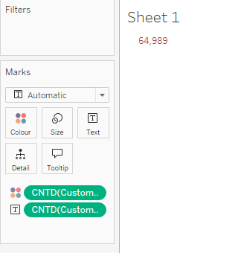

Insights: Number of customers registered for the program are **64,989**

1. **Total number of unique product category**

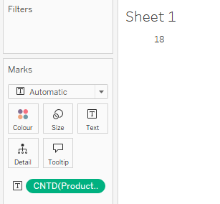

Insights: Total number of unique product category are **18**

1. **Find out the total sales and refund during the given period**

**Total Sales**

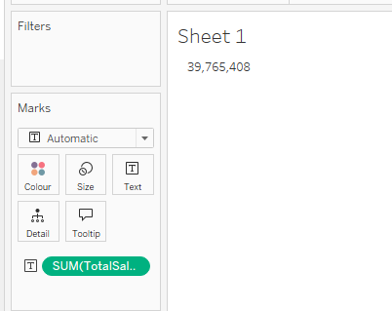

Total Spend

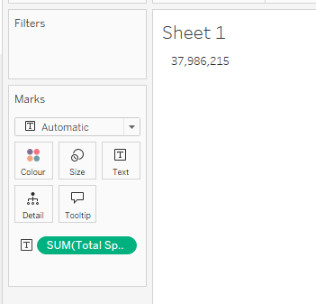

Insights: Total Sales are 3,97,65,408 and Total Spend are 37986215

1. **Percent sales contribution by each store city and store id to the total sales for the given period**

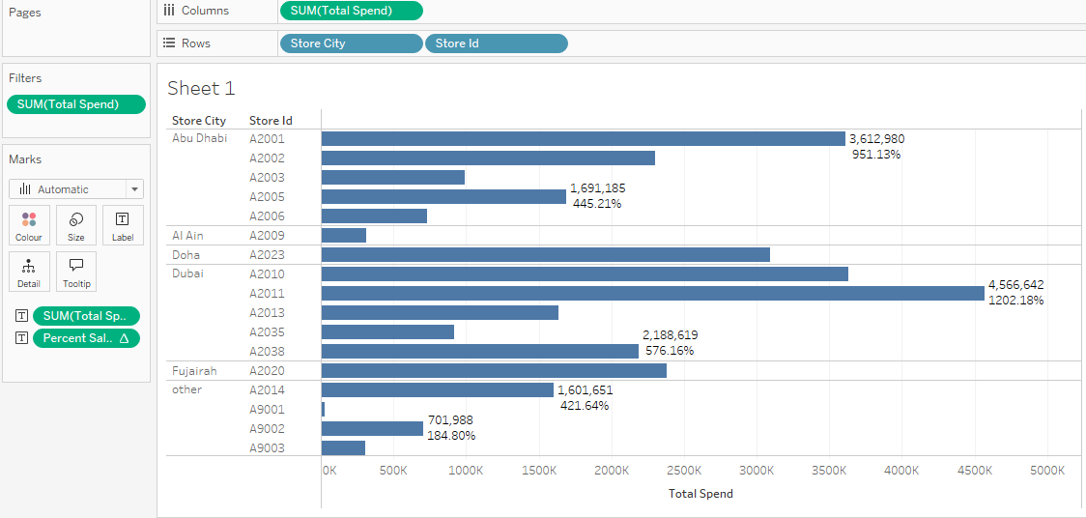

Insights: sales contribution is highest in Dubai A2011 Store ID, and least in Other store 9001 Store Id.

1. **Total number of items refunded during the period**

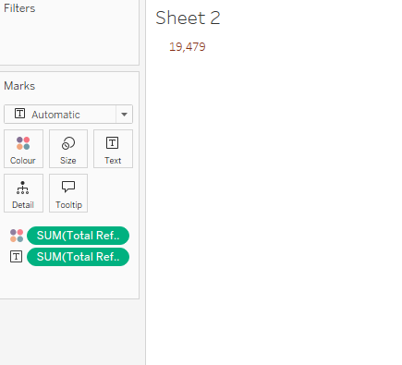

Insights: Total Number of refunded during the period is 19479.

1. **Total number of freebies given during the period**

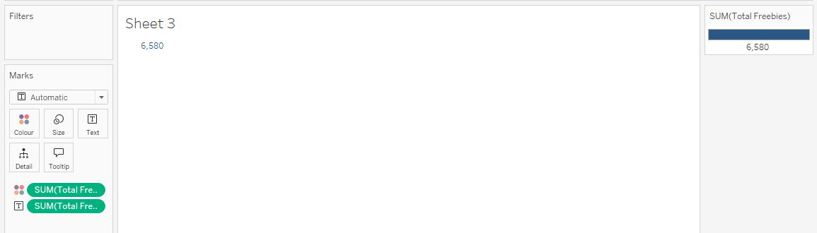

Insights: Total number of FREEBIES given are 6580

1. **Get the month on month trend of customers registration for the program**

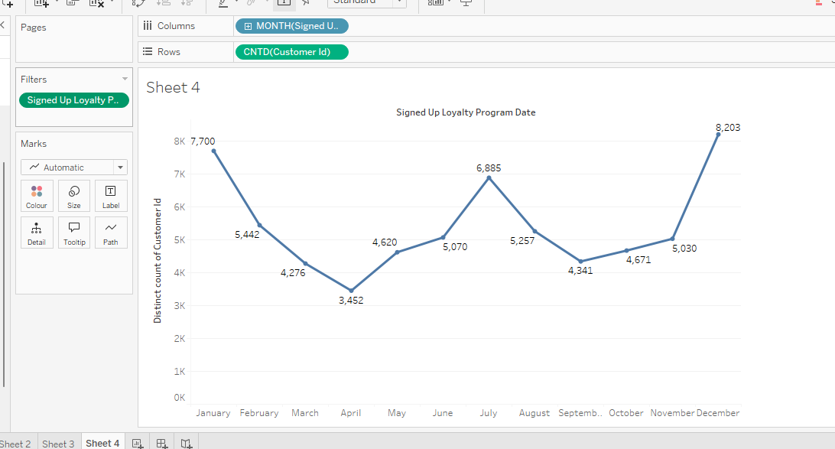

Insights: In December and January number of customers registered for the program are highest. In April the number of customers registered for the program is lowest.

1. **Get the month on month trend of customers registering on the app**

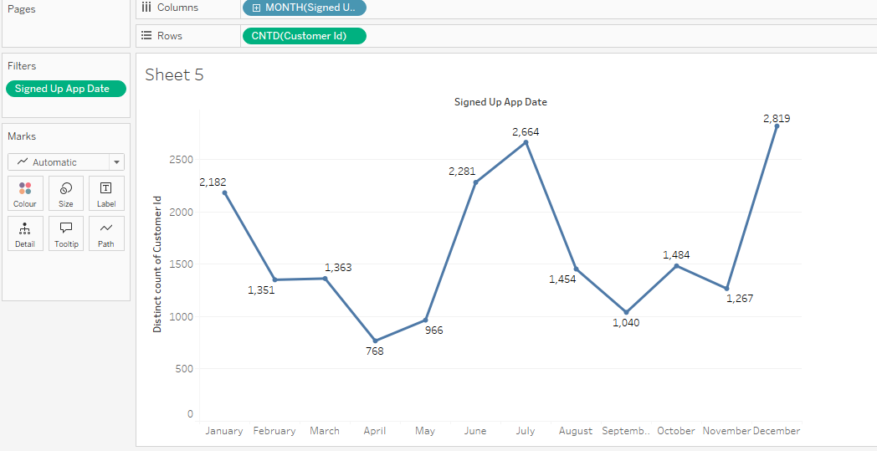

Insights: Number of customers registered on the app is highest in December and July whereas number of customers registered on the app is lowest in April month.

1. **Monthly trend in number of transaction of registered customers by current tier.**

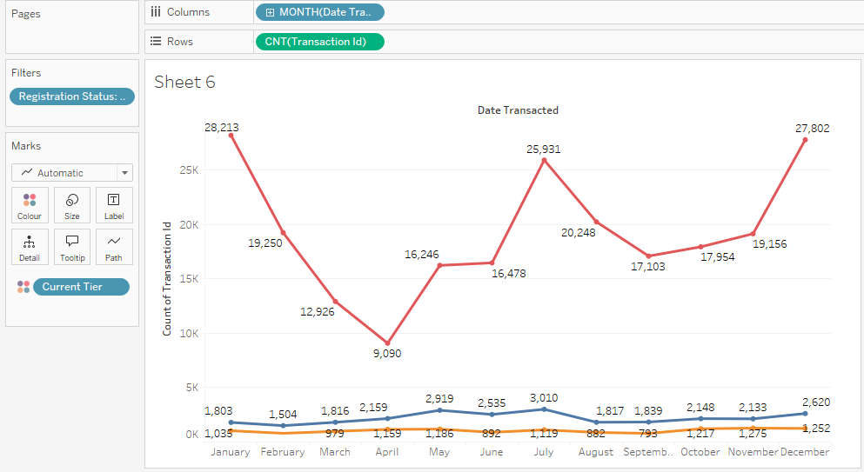

Insights: number of transactions of registered customers by current tier

1. **Top 10 customer nationality by number of customers signing up for loyalty program.**

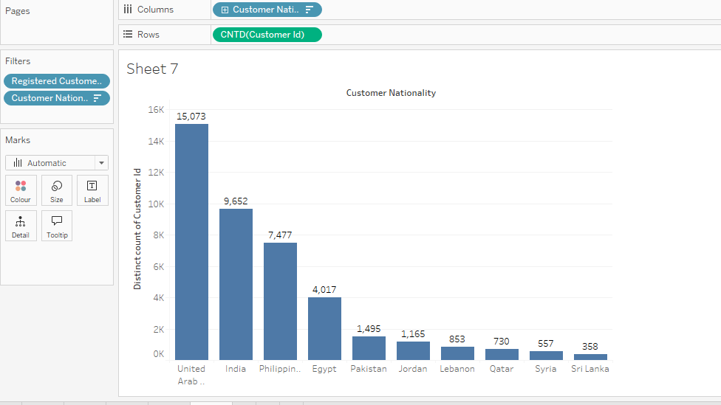

Insights: Screenshot shows the top 10 customer nationality by number of customers signing up for the loyalty program. Highest in United Arab and least in SriLanka.

1. **Count of customer from each country and number of customers based on current tier**

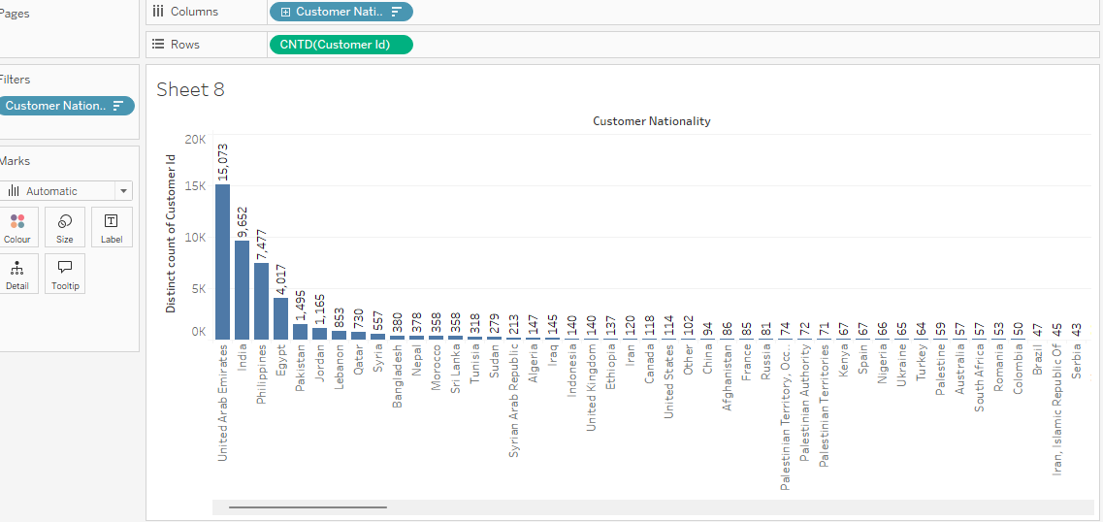

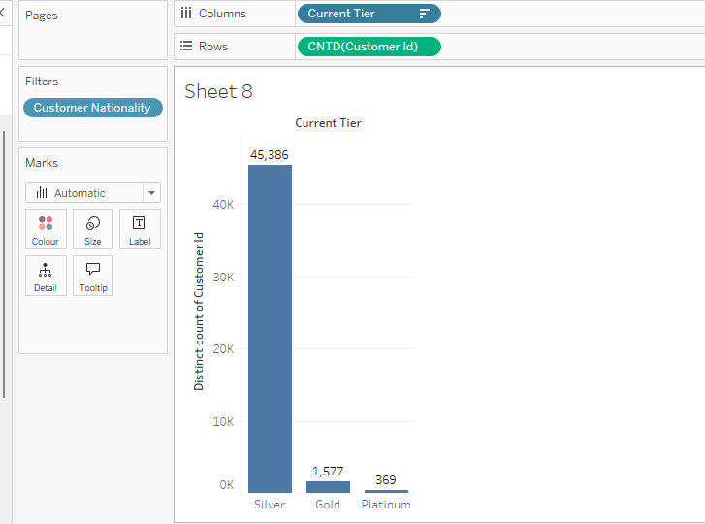

Insights: For silver tier number of customers are more. And platinum is lowest.

1. **Trend in Avg total spent by registered customers and not registered customers**

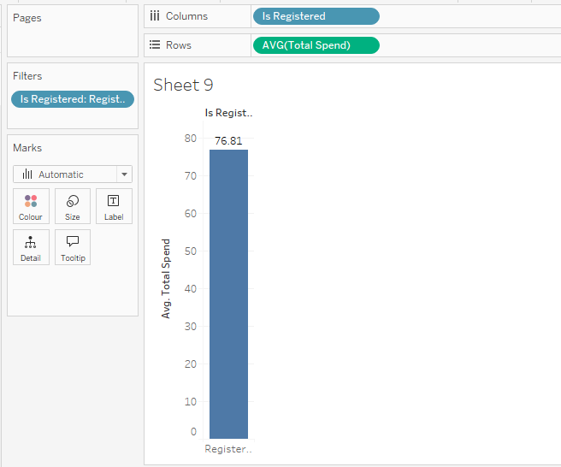

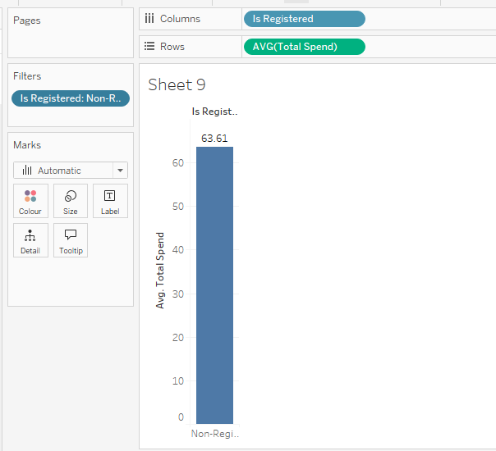

Insights: Average total spent by registered customers is 76.81 and not registered customers is 63.61

1. **Top 5 and bottom 5 items by number of transactions done**

**Top 5**

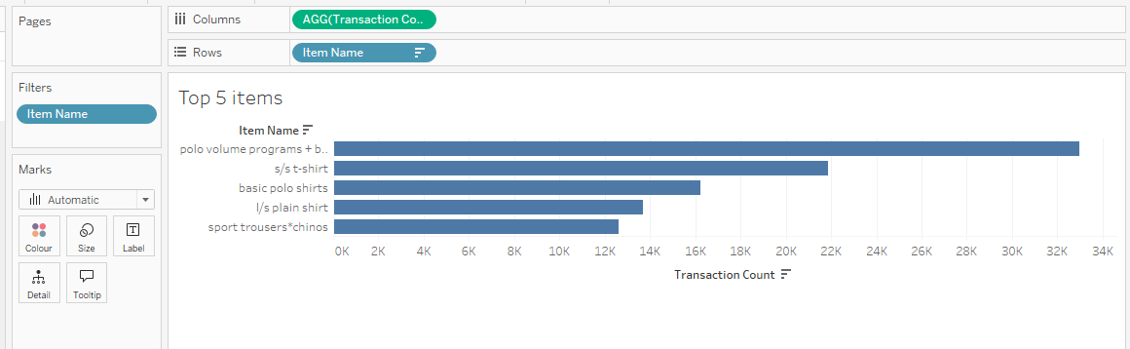

**Bottom 5**

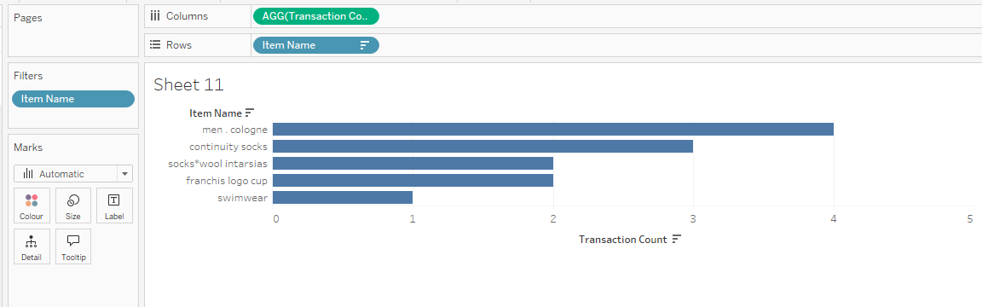

Insights: Top 5 Number of transactions done are shown in graph. Highest is in Polo Volume programs. Bottom 5 number of transactions done are shown in graph.

1. **Find items with most number of refunds**

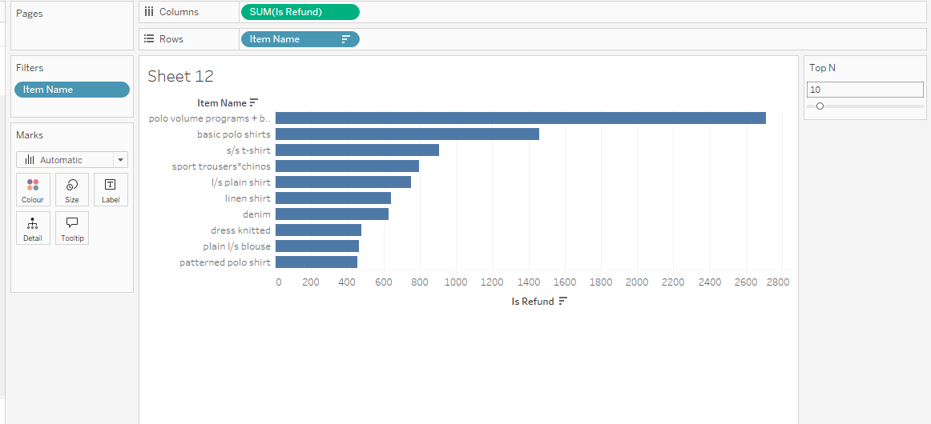

Insights: Most number of refunds are for polo volume programs item.

1. **Trend in number of transactions over time**

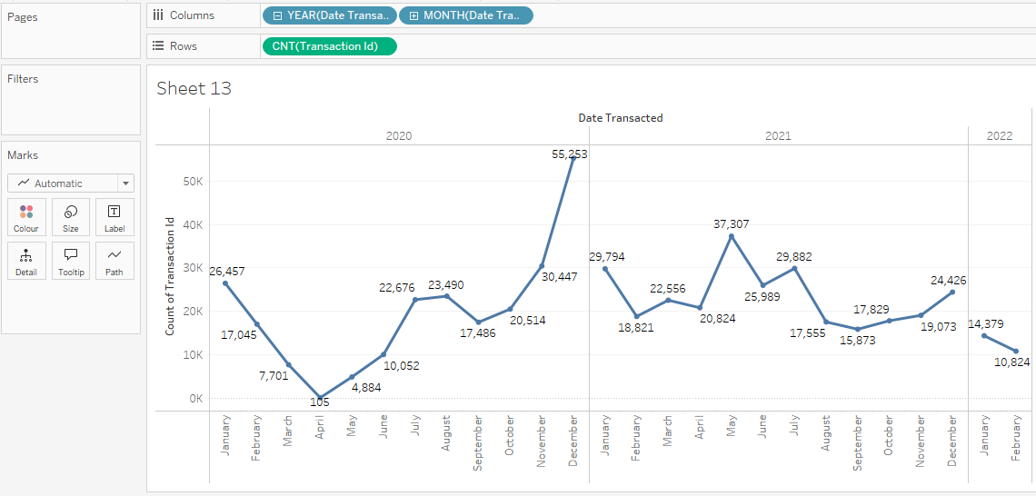

Insights: number of transactions are highest in December 2020 and lowest in April 2020.

1. **Top 10 trending product categories by average total spent**

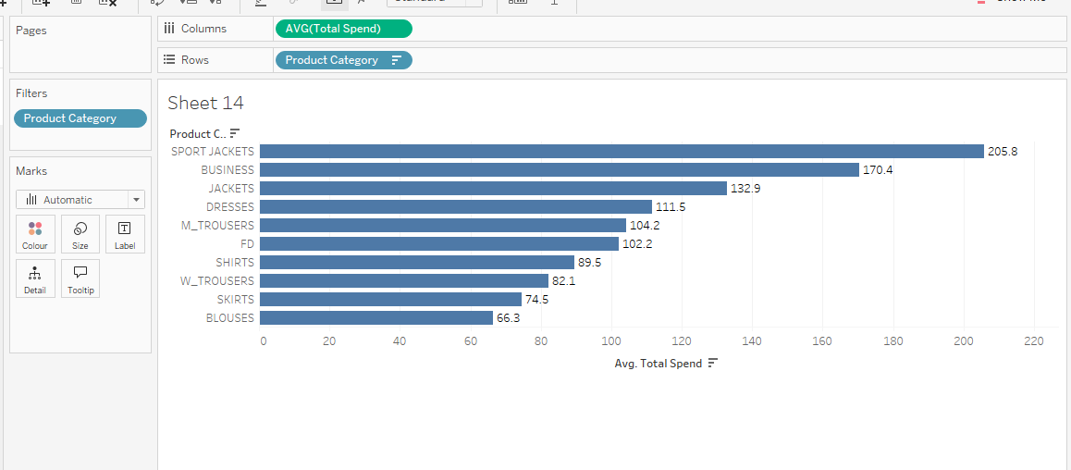

Insights: Top 10 trending product categories by total spent are shown in graph. Highest in Sport Jackets.

**Advanced Questions:**

1. **Percentage of registered customers signed up on app**

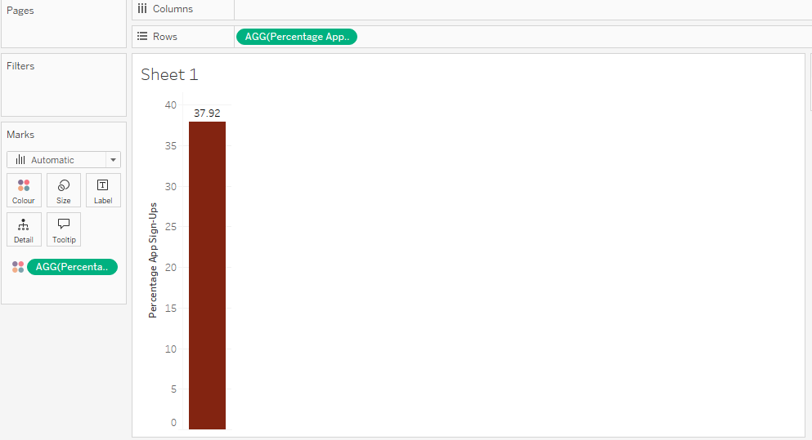

1. Insights: Percentage of registered customers signed up on app is 37.92
2. **Find out what is the average time period difference between customers registration date and 1st transaction date**

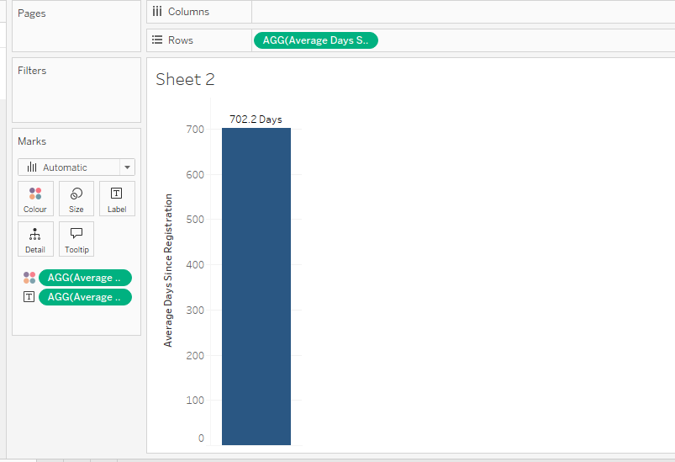

Insights: average time period difference between customers registration date and 1st transaction date is 702.2 days

1. **Percentage of registered customers where customer id is present but customer nationality is missing**

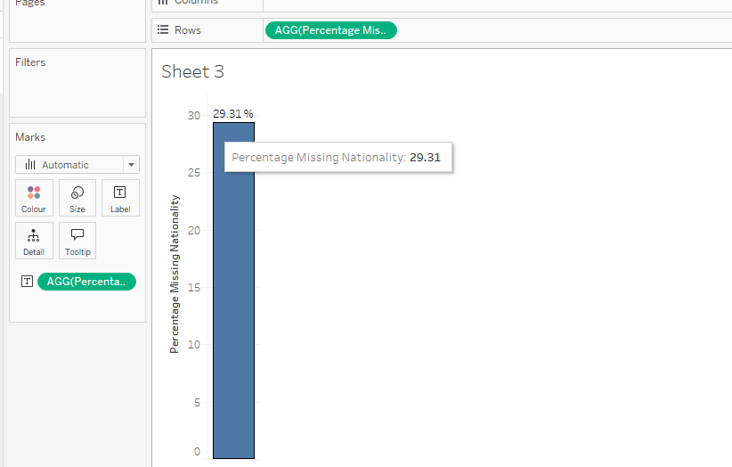

Insights: registered customers where customer id is present but customer nationality is missing is 29.31 %

1. **Find customer order frequency ie how many customers had done 1,2,3..N transactions.**

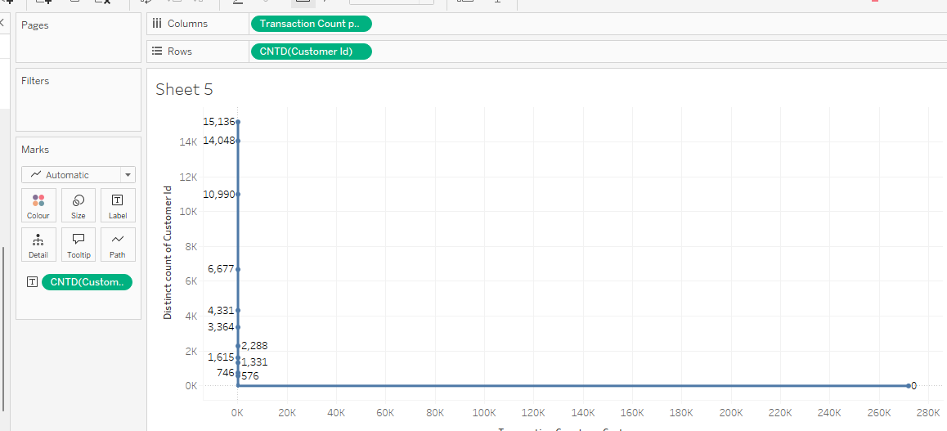

Insights:

1. **Year on Year customer retention who registered for the program.**

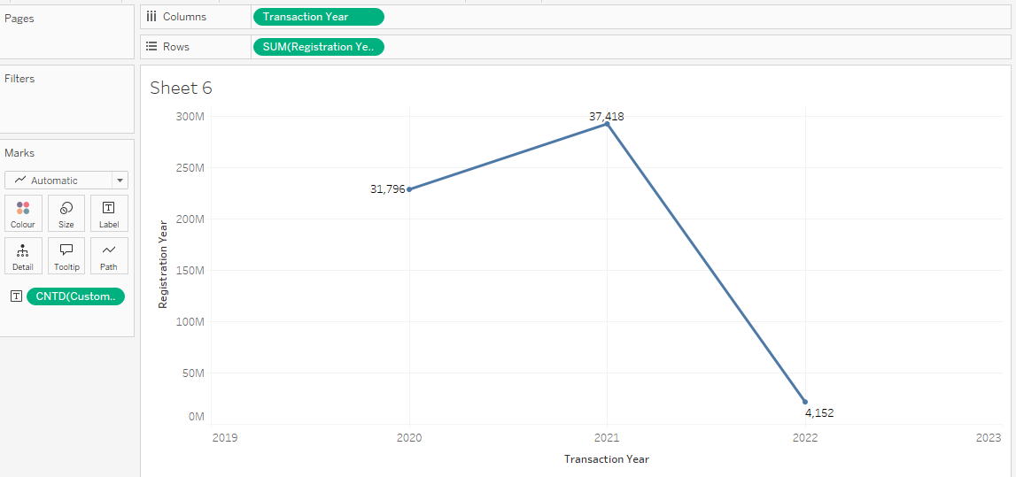

Insights: customer retention who registered for the program is highest in 2021 and lowest in 2022

1. **Month on Month count of new customers and repeat customers**

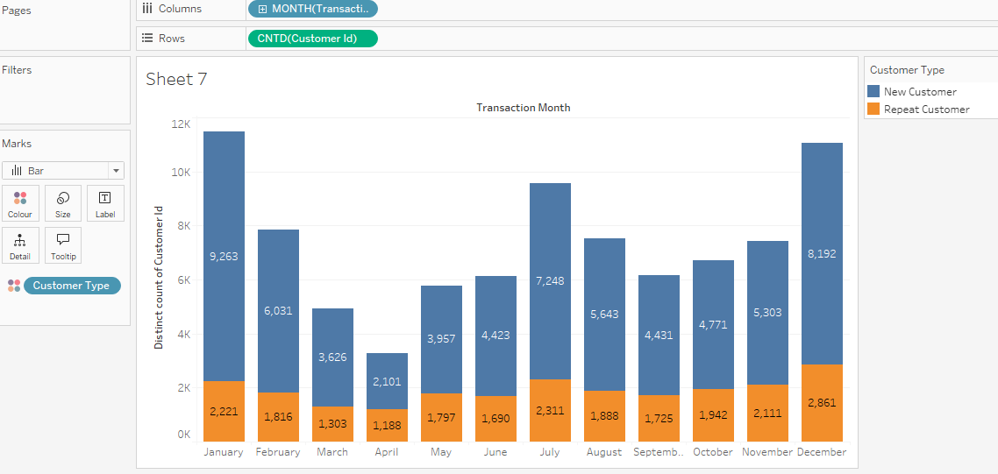

Insights: Count of new customers are more than repeat customers. This means lot of new customers are using the app.

1. **Month on month average transaction value(revenue/# of transaction for given time period)**

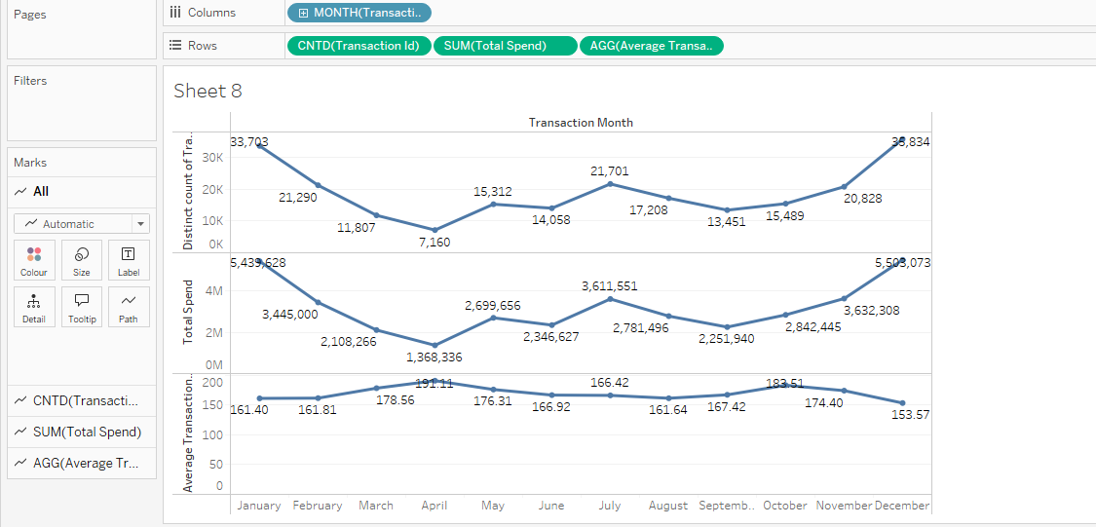

Insights:

1. **Month on month trend in units sold per transaction(number of units sold/# of transaction)**

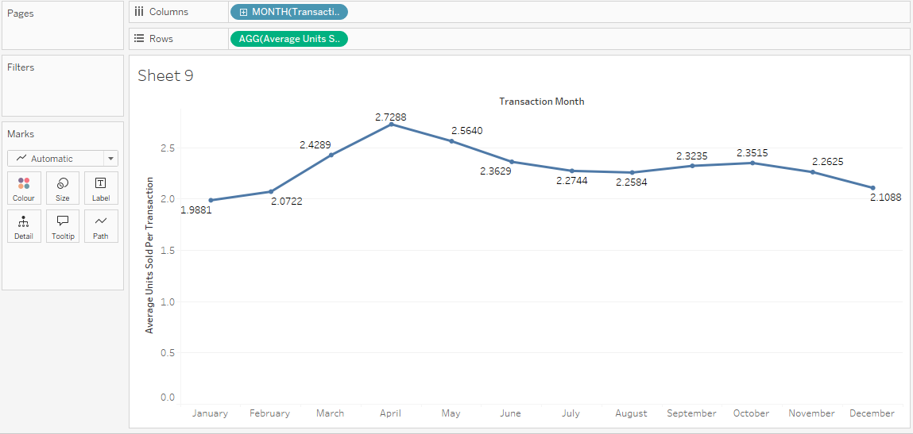

Insights:

1. **Find out the basket size for each product category**

* **Basket size=Total number of units sold/Total number of transactions**
* **Basket size tells us about number of units sold per transaction. A large basket size may indicate that your store is doing a good job at fulfilling shoppers’ needs.**

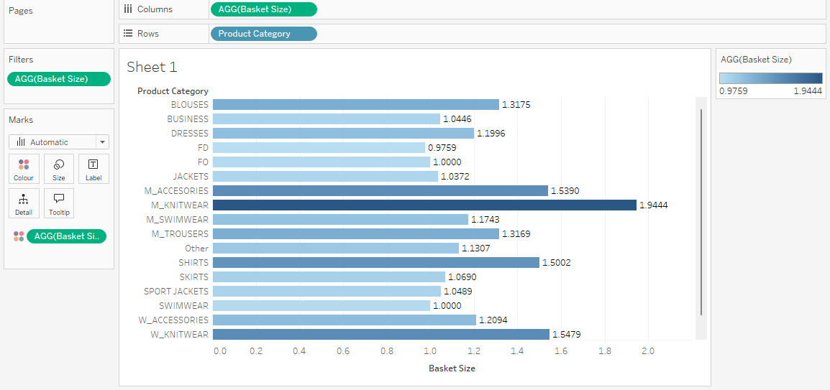

Insights: